**Built in class attributes and Methods**

write a program to implement the following build in class attributes and methods  
Class Attributes:

1. __dict__   
   __doc__   
   __name__   
   __module__   
   __bases__

class sample:

'''My documen'''

def test(self):

'''Test Document'''

print("Hello")

pass

ob=sample()

ob.a=12

ob.b=13

print("Dict",sample.__dict__)

print("DOC",sample.__doc__)

print("Name",sample.__name__)

print("Module",sample.__module__)

print("bases",sample.__bases__)

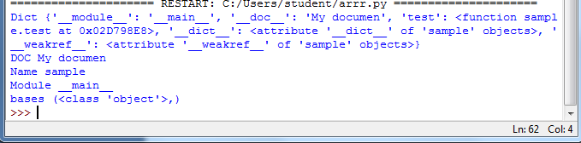

2..Class Methods:  
getattr(obj, name)   
hasattr(obj,name)   
setattr(obj,name,value)   
delattr(obj, name)

class sample:

a=10

def test(self):

print("a=",self.a,"b=",self.b)

pass

ob=sample()

setattr(ob,'b',30)

print("Get",getattr(ob,'a'))

ob.test()

print("Has",hasattr(ob,'b'))

print("Has",hasattr(ob,'x'))

delattr(ob,'b')

print("Has",hasattr(ob,'b'))

